* + 1. Problem Set

A small grocery store has only one checkout counter. Customers arrive at this checkout counter at random from 1 to 8 minutes apart. Each possible value of inter arrival time has the same probability of occurrence. The service times vary from 1 to 6 minutes with the probabilities shown in table 2. The problem is to analyze the system by simulating the arrival and service of 6 customers.

**Table.1 Distribution of arrived time**

|  |  |  |  |  |  |  |  |  |
| --- | --- | --- | --- | --- | --- | --- | --- | --- |
| **Interarrival**  **time (Min)** | 1 | 2 | 3 | 4 | 5 | 6 | 7 | 8 |
| **Probability** | 0.125 | 0.125 | 0.125 | 0.125 | 0.125 | 0.125 | 0.125 | 0.125 |

**Table-2 Distribution of service time**

|  |  |  |  |  |  |  |
| --- | --- | --- | --- | --- | --- | --- |
| **Service**  **time (Min)** | 1 | 2 | 3 | 4 | 5 | 6 |
| **Probability** | 0.20 | 0.10 | 0.30 | 0.15 | 0.20 | 0.05 |

**Calculate the following:**

1. The average waiting time for a customer
2. The probability that a customer has to wait in the queue
3. The fraction of idle time of the server
4. The average service time
5. The average time between arrivals
6. The average waiting time of those who wait
7. The average time a customer spends in the system.

Use the following sequence of random number,

Random digit for arrival are: 905, 727, 125, 848, 609.

Random digit for service time are: 14, 30, 94, 53, 37, 79.

* + 1. Solution:

Calculate arrival time distribution and assign a random number,

|  |  |  |  |
| --- | --- | --- | --- |
| **Time between arrival** | **Probability** | **Cumulative probability** | **Random digit assignment** |
| 1 | 0.125 | 0.125 | 00 – 125 |
| 2 | 0.125 | 0.250 | 126 – 250 |
| 3 | 0.125 | 0.375 | 251 – 375 |
| 4 | 0.125 | 0.500 | 376 - 500 |
| 5 | 0.125 | 0.625 | 501 - 625 |
| 6 | 0.125 | 0.750 | 626 – 750 |
| 7 | 0.125 | 0.875 | 751 – 875 |
| 8 | 0.125 | 1.000 | 876 - 000 |

Calculate service time distribution and assign a random number,

|  |  |  |  |
| --- | --- | --- | --- |
| **Service time** | **Probability** | **Cumulative probability** | **Random digit assignment** |
| 1 | 0.20 | 0.20 | 00 - 20 |
| 2 | 0.10 | 0.30 | 21 – 30 |
| 3 | 0.30 | 0.60 | 31 – 60 |
| 4 | 0.15 | 0.75 | 61 – 75 |
| 5 | 0.20 | 0.95 | 76 - 95 |
| 6 | 0.05 | 1.00 | 96 - 00 |

Determining time between arrival,

|  |  |  |
| --- | --- | --- |
| **Customer** | **Random Digit** | **IAT** |
| 1 | - | - |
| 2 | 905 | 8 |
| 3 | 727 | 6 |
| 4 | 125 | 1 |
| 5 | 848 | 7 |
| 6 | 609 | 5 |

Determining service time,

|  |  |  |
| --- | --- | --- |
| **Customer** | **Random Digit** | **Service time** |
| 1 | 14 | 1 |
| 2 | 30 | 2 |
| 3 | 94 | 5 |
| 4 | 53 | 3 |
| 5 | 37 | 3 |
| 6 | 79 | 5 |

**Simulation Table**

|  |  |  |  |  |  |  |  |  |
| --- | --- | --- | --- | --- | --- | --- | --- | --- |
| **Customer** | **IAT** | **Arrival Time** | **Service time** | **Time service begins** | **Waiting time** | **Time service ends** | **Time spent in system** | **Idle time of server** |
| 1 | - | 0 | 1 | 0 | 0 | 1 | 1 | 0 |
| 2 | 8 | 8 | 2 | 8 | 0 | 10 | 2 | 7 |
| 3 | 6 | 14 | 5 | 14 | 0 | 19 | 5 | 4 |
| 4 | 1 | 15 | 3 | 19 | 4 | 22 | 7 | 0 |
| 5 | 7 | 22 | 3 | 22 | 0 | 25 | 3 | 0 |
| 6 | 5 | 27 | 5 | 27 | 0 | 32 | 5 | 2 |

**Here,**

$Total number of customer$ = 6,

$$Cumulative IAT = 27,$$

$Total service time= 19$,

$$Number of customers waiting in queue = 1,$$

$$Total time customer wait in queue=4,$$

$$Total idle time of server = 13,$$

$$Total run time of server = 32,$$

$$Total time spent in system=23$$

**Therefore,**

* + 1. Simulation in Excel:

Simulation Table,

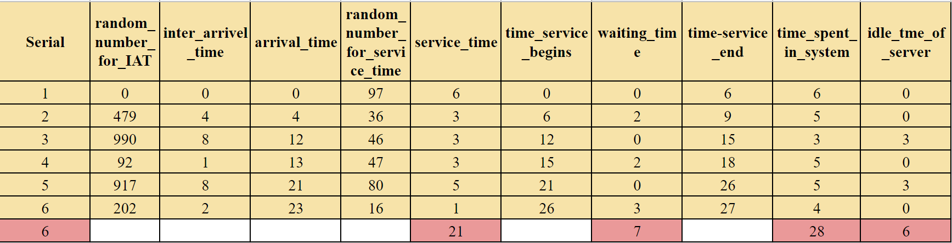

Value calculation,

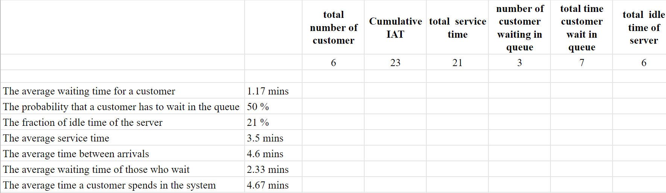

* + 1. Simulation using python:

**Code:**

$$from random import randrange$$

$$customer_in_server = []$$

$$ultimate_customer_info = []$$

$$customer_in_queue = []$$

$$rn_iat = 0$$

$$iat = 0$$

$$rn_st = 0$$

$$st = 0$$

$$stb = 0$$

$$wt = 0$$

$$its = 0$$

$$def inter_arrival_time(k):$$

$$for i in range(k):$$

$$if (i == 0):$$

$$customer_in_queue = [i, 0, 0, 0]$$

$$else:$$

$$global stb, wt, its$$

$$rn_iat = randrange(1000)$$

$$if (rn_iat < 126):$$

$$iat = 1$$

$$elif (rn_iat < 251):$$

$$iat = 2$$

$$elif (rn_iat < 376):$$

$$iat = 3$$

$$elif (rn_iat < 501):$$

$$iat = 4$$

$$elif (rn_iat < 626):$$

$$iat = 5$$

$$elif (rn_iat < 751):$$

$$iat = 6$$

$$elif (rn_iat < 876):$$

$$iat = 7$$

$$elif (rn_iat < 1001):$$

$$iat = 8$$

$$customer_in_server = customer_in_queue.copy()$$

$$customer_in_queue = [i, rn_iat, iat]$$

$$at = customer_in_server[3] + customer_in_queue[2]$$

$$customer_in_queue.append(at)$$

$$stb = max(customer_in_server[8], customer_in_queue[3])$$

$$wt = customer_in_server[8] - at$$

$$if wt < 0 :$$

$$wt = 0$$

$$its = at - customer_in_server[8]$$

$$if its < 0 :$$

$$its = 0$$

$$a, b = server_time()$$

$$customer_in_queue.append(a)$$

$$customer_in_queue.append(b)$$

$$customer_in_queue.append(stb)$$

$$customer_in_queue.append(wt)$$

$$tse = customer_in_queue[5] + customer_in_queue[6]$$

$$customer_in_queue.append(tse)$$

$$tsis = customer_in_queue[8] - customer_in_queue[3]$$

$$customer_in_queue.append(tsis)$$

$$customer_in_queue.append(its)$$

$$ultimate_customer_info.append(customer_in_queue)$$

$$def server_time():$$

$$rn_st = randrange(100)$$

$$if (rn_st < 21):$$

$$st = 1$$

$$elif (rn_st < 31):$$

$$st = 2$$

$$elif (rn_st < 61):$$

$$st = 3$$

$$elif (rn_st < 76):$$

$$st = 4$$

$$elif (rn_st < 96):$$

$$st = 5$$

$$elif (rn_st < 101):$$

$$st = 6$$

$$return rn_st, st$$

$$inter_arrival_time(6)$$

$$import pandas as pd$$

$$df = pd.DataFrame(ultimate_customer_info, columns = ['Customer no.', ' rn-iat ', ' iat ', ' at ', ' rn_st ', ' st ', ' stb ', ' wt ', ' tse ', ' tsis ', ' its '])$$

$$df=df.set_index('Customer no.')$$

$$print(df)$$

**Output:**

